

Lahore Campus
Web technologies
Lab Assignment 1
CV

Submitted to: Sir Usman Akram
Submitted by: Abdullah Saleem
Roll no: FA24-BCS-141
Section: B
Date: 25 Sep ,2026

Submitted to: Mr. Abdul-Karim
Submitted by: Abdullah Saleem
Roll no: FA24-BCS-141
Section: B
Date: 7 Nov,2024

Code :
cv.html
<!DOCTYPE html>
<html lang="en">
<head>
<meta charset="UTF-8">
<meta name="viewport" content="width=device-width, initial-scale=1.0">
<title>My Resume</title>
<link rel="stylesheet" href="Style.css">
</head>
<body>

<div>
<img src="profile photo.png" alt="Abdullah Saleem ">
</div>
<div>
<h1>Abdullah Saleem</h1>
<p>
Lahore, Pakistan | +923217990012 | <a href="abdullah.saleem20202@gmail.com">abdullah.saleem20202@gmail.com</a>

</p>
<p>
<a href="https://www.linkedin.com/in/abdullah-saleem-141-/"target =blank>Linkedin</a> |
<a href="https://github.com/Abdullah-Saleem-141"target = blank>Github</a>
</p>
</div>

<h2>Professional Summary</h2>
<p>
Computer Science undergraduate at COMSATS University Islamabad (Lahore Campus) with a strong interest in Artificial Intelligence, Machine Learning, Data Science, and Software Development. Experienced in building practical projects, learning modern technologies, and applying software engineering principles to solve real-world problems. Quick learner with strong analytical, problem-solving, and typing skills , committed to writing clean, maintainable code.
</p>

<h2>Core Skills</h2>
<p> <strong>Programming Fundamentals: </strong> Python, Java, C++, SQL, JavaScript</p>
<p><strong>Libraries & Frameworks:</strong> NumPy, Pandas, Scikit-learn, TensorFlow, PyTorch, OpenCV, JavaFX</p>
<p><strong>Tools & Platforms:</strong>Git, GitHub, Visual Studio Code, IntelliJ IDEA, Microsoft Excel</p>
<p><strong>Areas of Interest: </strong>Artificial Intelligence, Machine Learning, Deep Learning, Computer Vision, Software Development</p>

<h2>Projects</h2>

<h3><strong>Cricket Match Win Probability Predictor</strong> | <em> Python, FastAPI, Streamlit, XGBoost, Pandas </em></h3>
<ul>
<li>Developed a machine learning web application predicting pre-match win probabilities for T20 cricket matches using historical data.</li>
<li>Engineered advanced features including Elo ratings, recent team form, head-to-head records, and venue statistics.</li>
<li> Built a FastAPI backend for analytics APIs and a Streamlit frontend providing interactive dashboards and probability visualizations.</li>

</ul>

<h3><strong>Hostel Complaint System</strong> | <em>Java, Servlets, JSP, PostgreSQL, Apache Tomcat</em></h3>
<ul>
<li>Designed and implemented a web-based complaint management platform for tracking and resolving hostel maintenance tickets.</li>
<li>Provided a centralized portal for students to submit complaints and administrative staff to manage lifecycle updates.</li>
<li>• Utilized MVC architecture, HikariCP for database connection pooling, and PostgreSQL for backend data persistence.</li>
</ul>

<h3><strong> Rent Management System</strong> | <em>Node.js, Express.js, EJS, SQLite, Chart.js</em></h3>
<ul>
<li>Created a centralized property rental management application handling tenants, rental records, and administrative tasks.</li>
<li>Integrated secure user authentication, session management, and integrated data visualizations via Chart.js for tracking financials.</li>

</ul>

<h3><strong>Maze Explorer</strong> | <em>Java, JavaFX / GUI</em></h3>
<ul>
<li>Built an interactive algorithm visualization application to demonstrate graph traversal strategies on grid-based mazes.</li>
<li>Implemented real-time visual animations for Breadth-First Search (BFS) and Depth-First Search (DFS) pathfinding algorithms.</li>
</ul>

<h2>Education</h2>

<h3>COMSATS University Islamabad (2024-2028) (Expected)</h3>
<p>Bachelor of Science in Computer Science | (Current Semester: 5 )</p>

<h3>Punjab College, Pattoki Campus (2022-2024)</h3>
<p>Intermediate (FSc) | Marks: 1029 / 1200 (Grade: A+)</p>

<h3>Paragon Public High School, Pattoki (2020-2022) </h3>
<p>Matriculation | Marks: 1064 / 1100 (Grade: A+)</p>

<h2>Certifications</h2>
<h3><strong>CS50: Cybersecurity</strong>
<p>Credential Verification: <a href="https://cs50.harvard.edu/cybersecurity/"target = blank>View Credencials</a></p></h3>

<h3><strong>Google Sheets Certificate</strong>
<p>Credential Verification: <a href="https://www.coursera.org/account/accomplishments/verify/339B1XXFJYHC" target = blank> View Credencials</a></p></h3>

</body>
</html>

Css.Style
body {
font-family: Arial;
margin: 40px;
color: black;
}

div {
text-align: center;
}

h1 {
margin: 0;
font-size: 28px;
color: black;
}

h2 {
font-size : 16px;
color : midnightblue;
border-bottom : 2px solid midnightblue;
padding-bottom : 5px;
margin-top : 20px;
}

h3 {
font-size : 14px;
color : black;

}

p {
margin: 5px 0;
font-size: 14px;
color : #555;
}

a {
color: blue;
text-decoration: none;
}

a:hover {
text-decoration: underline;
}
Strong {
color : midnightblue
}

ul {
margin-top : 5px;
margin-bottom : 15px;
font-size : 12px;
color : #555
}

img {
width : 150px;
hight : 150px;
object-fit : cover;
border-radius : 50%;

}

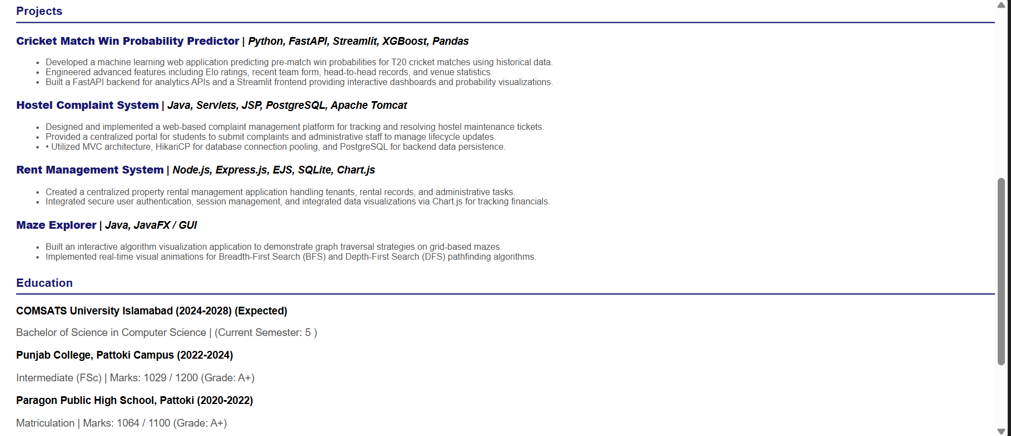
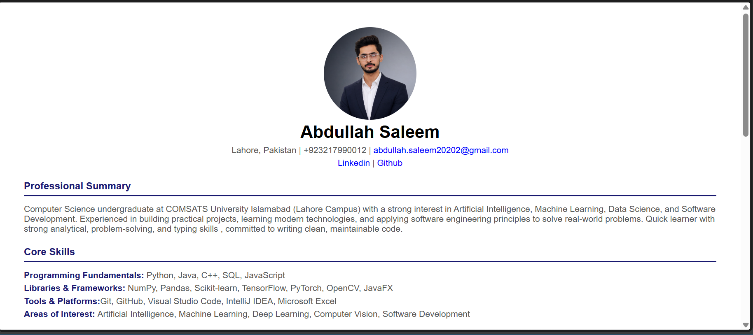
Output:
